A project report on
PERSONALIZED CONTEXTUAL HINT GENERATION SYSTEM
Submitted in partial fulfillment for the award of the degree of

Bachelor of Technology in Computer Science and Engineering (Artificial Intelligence and Machine Learning)

by
SAUMYA AGARWAL (23BAI1588)
KAVYA R (23BCE1154)
MEGHNA MANDAWRA (23BAI1196)

SCHOOL OF COMPUTER SCIENCE AND ENGINEERING
October, 2026

DECLARATION
I hereby declare that the thesis entitled “PERSONALIZED CONTEXTUAL HINT GENERATION SYSTEM” submitted by KAVYA R (23BCE1154), for the award of the degree of Bachelor of Technology in Computer Science and Engineering, Vellore Institute of Technology, Chennai is a record of bonafide work carried out by me under the supervision of PRAKASH P.
I further declare that the work reported in this thesis has not been submitted and will not be submitted, either in part or in full, for the award of any other degree or diploma in this institute or any other institute or university.

Place: Chennai
Date: 13/10/2026

Signature of the Candidate

School of Computer Science and Engineering
CERTIFICATE
This is to certify that the Capstone Project Report entitled "Personalized Contextual Hint Generation System" submitted by Saumya Agarwal (23BAI1588), Meghna Mandawra (23BAI1196), and Kavya R (23BCE1154) to the Vellore Institute of Technology, Chennai, in partial fulfilment of the requirements for the award of the degree of Bachelor of Technology in Computer Science and Engineering (Artificial Intelligence and Machine Learning) is a bonafide record of work carried out under my supervision during the academic year 2025–2026.

Signature of the Guide:
Name: Prof. Prakash P
Date:

Signature of the Examiner Signature of the Examiner
Name: Name:
Date: Date:

Approved by the Head of Department,
Computer Science and Engineering
(Artificial Intelligence and Machine Learning)

Name: Dr. Tulasi Prasad Sariki
Date:

(Seal of SCHOOL YOU BELONG TO)
ABSTRACT

Programming education at scale faces a fundamental challenge: determining when a student's struggle is productive—leading them toward understanding—versus when it is unproductive and requires external intervention. Existing intelligent tutoring systems for programming either generate hints on explicit request or rely on single-snapshot code analysis, without distinguishing the nature of a learner's ongoing struggle process. This capstone project presents a Personalized Contextual Hint Generation System that integrates trajectory-based struggle assessment with adaptive, progressive hint delivery.
The system constructs chronological interaction trajectories from student programming attempts, extracting features across six research dimensions: code evolution, error evolution, test performance progression, exploration and approach changes, temporal behaviour, and repetition/stagnation patterns. Four assessment methodologies are compared: M1 (Snapshot Baseline), which evaluates only the latest attempt; M2 (Trajectory-Based Signal Assessment), Uses patterns across a student's attempts to decide whether they are making progress or getting stuck; M3 (LLM Trajectory Reasoning), which uses a large language model to reason over the entire trajectory; and M4 (Refined Hybrid), which fuses objective rule-based features with LLM reasoning through an interpretable evidence-fusion layer.
Each method classifies the student's struggle state as PRODUCTIVE, UNPRODUCTIVE, or UNCERTAIN, and maps the assessment to an intervention policy: continue (wait), monitor, or intervene. When intervention is warranted, the system delivers progressive, context-aware hints through a multi-agent pipeline comprising an Attempt Analyzer, Pedagogical Strategist, Hint Generator, and Hint Critic. The hints are generated based on the student's attempt history, while an additional Retrieval-Augmented Generation (RAG) module retrieves relevant concepts and examples from previously attempted problems when such history is available.

The platform uses a Django REST Framework backend and a React frontend, supporting code execution in multiple programming languages through the Piston API, over 1,000 curated coding problems, community features, and detailed analytics. The system is evaluated using controlled experiments based on different attempt patterns (P1–P10) (see Appendix 1), comparisons between assessment methods, and a human annotation protocol to support future empirical validation. The main research contribution is the integration of trajectory-based assessment of productive and unproductive struggle with adaptive intervention decisions and progressive, context-aware hint generation, bringing these related aspects together within a single intelligent tutoring system.
Keywords: Intelligent Tutoring Systems, Productive Struggle, Trajectory Analysis, Hint Generation, Large Language Models, Adaptive Intervention, Programming Education.

ACKNOWLEDGEMENT
It is my pleasure to express with deep sense of gratitude to Mr. Prakash P, Associate Professor, School of Computer Science and Engineering, Vellore Institute of Technology, Chennai, for his constant guidance, continual encouragement, understanding; more than all, he taught me patience in my endeavor. My association with him is not confined to academics only, but it is a great opportunity on my part of work with an intellectual and expert in the field of artificial intelligence and machine learning.
It is with gratitude that I would like to extend my thanks to the visionary leader Dr. G. Viswanathan our Honorable Chancellor, Mr. Sankar Viswanathan, Dr. Sekar Viswanathan, Dr. G V Selvam Vice Presidents, Dr. Sandhya Pentareddy, Executive Director, Ms. Kadhambari S. Viswanathan, Assistant Vice-President, Dr. V. S. Kanchana Bhaaskaran Vice-Chancellor, Dr. T. Thyagarajan Pro-Vice Chancellor, VIT Chennai and Dr. P. K. Manoharan, Additional Registrar for providing an exceptional working environment and inspiring all of us during the tenure of the course.
Special mention to Dr. Viswanathan V, Dean, Dr. Nithyanandam P, Associate Dean, Dr. Suganya G, Associate Dean, Dr. Sweetlin Hemalatha C, Associate Dean, School of Computer Science and Engineering, Vellore Institute of Technology, Chennai for spending their valuable time and efforts in sharing their knowledge and for helping us in every aspect.
In jubilant state, I express ingeniously my whole-hearted thanks to Dr. Tulasi Prasad Sariki, Head of the Department, B.Tech. Computer Science and Engineering (Artificial Intelligence and Machine Learning) and the Project Coordinators for their valuable support and encouragement to take up and complete the thesis.
My sincere thanks to all the faculties and staffs at Vellore Institute of Technology, Chennai who helped me acquire the requisite knowledge. I would like to thank my parents for their support. It is indeed a pleasure to thank my friends who encouraged me to take up and complete this task.
Place: Chennai
Date: Saumya Agarwal

TABLE OF CONTENTS
S. No. | Contents | Pg No.
1 | Declaration | 2
2 | Certificate | 3
3 | Abstract | 4
4 | Acknowledgement | 6
5 | Table of Contents | 7
6 | List of Tables | 9
7 | List of Figures | 10
8 | List of Abbreviations | 11
9 | CHAPTER 1: INTRODUCTION | 12
9.1 | Background | 12
9.2 | Problem Statement | 13
9.3 | Motivation | 13
9.4 | Research Question | 14
9.5 | Objectives | 15
9.6 | Scope of the Project | 15
9.7 | Contributions | 17
9.8 | Report Organisation | 18
10 | CHAPTER 2: LITERATURE REVIEW | 19
10.1 | Traditional Data-Driven Hint Generation | 19
10.2 | LLM-Based Programming Hints | 21
10.3 | Hint Quality Evaluation | 22
10.4 | Adaptive Timing and Learner Context | 22
10.5 | Survey and Synthesis | 23
10.6 | Research Gap and Proposed Direction | 24
11 | CHAPTER 3: METHODOLOGY AND SYSTEM DESIGN | 26
11.1 | Research Methodology Overview | 26
11.2 | Trajectory Construction and Feature Extraction | 26
11.3 | Struggle Assessment Methods (M1–M4) | 30
11.4 | Intervention Policy | 35
11.5 | Hint Generation Pipeline | 36
11.6 | System Architecture | 38
11.7 | Database Design | 40
11.8 | API Design | 41
11.9 | Evaluation Design | 41
12 | CHAPTER 4: IMPLEMENTATION AND RESULTS | 44
12.1 | Technology Stack | 44
12.2 | Implementation Details | 44
12.3 | Testing and Quality Assurance | 47
12.4 | Controlled Pattern Experiment Results | 48
12.5 | Method Agreement Analysis | 49
12.6 | Case Studies | 50
12.7 | Error Analysis and Limitations | 51
12.8 | Results | 52
12.9 | Findings Summary | 55
13 | CHAPTER 5: CONCLUSION AND FUTURE WORK | 56
13.1 | Summary of Work | 56
13.2 | Objectives Achieved | 56
13.3 | Limitations | 57
13.4 | Future Work | 57
14 | REFERENCES | 59
15 | APPENDICES | 61

LIST OF TABLES

Table 2.1: Comparison of Existing Hint Generation Systems
Table 3.1: Trajectory Transition Feature Catalog (Six Research Dimensions)
Table 3.2: Productive Struggle Signals (P1–P5)
Table 3.3: Unproductive Struggle Signals (U1–U6)
Table 3.4: Rule-Based Baseline Configuration Parameters
Table 3.5: Hybrid Fusion Configuration Parameters
Table 3.6: Intervention Policy Mapping
Table 3.7: Database Entity Relationship Summary
Table 3.8: REST API Endpoint Summary
Table 4.1: Technology Stack Summary
Table 4.2: Controlled Pattern Experiment Results (P1–P10)
Table 4.3: Method Agreement Rates Across Assessment Conditions
Table 4.4: Dataset & Benchmark Setup
Table 4.5: Method Taxonomy (M1–M4)
Table 4.6: Benchmark Performance Comparison
Table 4.7: Confusion Matrix of LLM Rephrasing (M3)
Table 4.8: Confusion Matrix of Refined Hybrid Model (M4)

LIST OF FIGURES

Figure 3.1: Trajectory Construction Pipeline
Figure 3.2: Six-Dimensional Transition Feature Extraction
Figure 3.3: M2 Rule-Based Assessment Signal Detection Flow
Figure 3.4: Multi-Agent Hint Generation Pipeline
Figure 3.5: Overall System Architecture
Figure 3.6: Database Entity-Relationship Diagram
Figure 3.7: Temporal Prefix Experiment Framework
Figure 4.1 Problem Detail Page
Figure 4.2 Annotations Page
Figure 4.3 Attempt History
Figure 4.4: Accuracy And Balanced Accuracy Comparison

LIST OF ABBREVIATIONS

Abbreviation | Full Form
AI | Artificial Intelligence
API | Application Programming Interface
AST | Abstract Syntax Tree
CTD | Contextual Tree Decomposition
DRF | Django REST Framework
ITS | Intelligent Tutoring System
JWT | JSON Web Token
LLM | Large Language Model
NLP | Natural Language Processing
RAG | Retrieval-Augmented Generation
REST | Representational State Transfer
TF-IDF | Term Frequency–Inverse Document Frequency
UI | User Interface

CHAPTER 1
INTRODUCTION

1.1 Background
Programming education has experienced rapid growth globally, with millions of learners engaging with coding platforms, massive open online courses, and university curricula that increasingly emphasise computational thinking. However, learning to program remains inherently challenging. Novice programmers routinely encounter compilation errors, logical mistakes, and algorithmic misunderstandings that can lead to frustration and disengagement. In traditional classroom settings, human tutors can observe a student's process—not merely their final submission—and intervene when struggle becomes unproductive. At scale, this level of individual attention is infeasible, creating a pressing need for intelligent tutoring systems (ITS) that can replicate this nuanced pedagogical decision-making.
Intelligent tutoring systems for programming have evolved substantially over the past two decades. Early data-driven tutoring approaches, such as the Hint Factory proposed by Barnes and Stamper (2008), analyzed students past problem-solving attempts to generate relevant hints for their next steps. Extensions including the Continuous Hint Factory (Paaßen et al., 2018) and Contextual Tree Decomposition (Price et al., 2017) addressed the challenge of sparse programming state spaces by introducing continuous representations and AST-based decomposition. More recently, the emergence of large language models (LLMs) has enabled a new generation of systems that can generate flexible natural-language programming hints without requiring extensive historical datasets (Roest et al., 2024; Liffiton et al., 2024).
Despite these advances, a critical gap persists: the distinction between when a student should be left to continue struggling productively and when external intervention is necessary. Productive struggle—the experience of difficulty that drives meaningful learning—is a well-established concept in educational research (Kapur, 2008). A student who encounters errors but systematically modifies their approach, resolves compilation issues, and progressively improves their test pass rate is engaging in productive struggle. Conversely, a student who repeatedly submits identical code, encounters the same error, and makes no meaningful progress is struggling unproductively and requires assistance. Most existing systems either wait for an explicit hint request or apply simplistic heuristics (e.g., three consecutive failures), failing to capture the temporal dynamics of the learning process.
1.2 Problem Statement
Current automated programming tutoring systems face three interrelated limitations:
First, most systems assess student difficulty based on a single code snapshot—the latest submitted attempt—without considering the history of how that attempt evolved. A failed submission alone does not reveal whether a student is struggling productively. It may be an initial attempt at an unfamiliar problem or a repeated execution of unchanged code that continues to fail. Without trajectory context, the system cannot distinguish these cases.
Second, even systems that do track attempt history typically apply fixed thresholds (e.g., intervene after three failures) rather than analysing the qualitative evolution of the student's code, errors, test results, and problem-solving approach over time. This ignores the rich behavioural signals embedded in the interaction sequence.
Third, hint generation and intervention timing are treated as separate concerns. A system may generate high-quality hints but deliver them at the wrong time—interrupting productive exploration or failing to intervene during sustained stagnation.
The problem addressed by this project is therefore: How can an intelligent tutoring system analyse a student's chronological programming interaction trajectory to assess whether their struggle is productive or unproductive, and use this assessment to make informed, context-aware decisions about when and how to provide adaptive, progressive hints?
1.3 Motivation
This project is driven by several key challenges and research needs:
Educational Theory: The concept of productive struggle, rooted in constructivist learning theory, suggests that appropriate difficulty promotes deeper understanding. However, this benefit is lost when struggle becomes unproductive—when the learner is unable to make progress and lacks the metacognitive awareness to recognise their impasse. An effective tutoring system must preserve productive struggle while rescuing learners from unproductive cycles.
Scale of the Problem: With competitive programming platforms, MOOCs, and university courses serving millions of students, human tutoring cannot scale. Automated systems that can replicate the observational and interventional capabilities of expert tutors are essential for equitable access to high-quality programming instruction.
Advances in LLM Capabilities: Large language models have demonstrated the ability to generate contextually relevant, pedagogically appropriate hints for programming tasks. However, their integration with systematic struggle assessment and intervention timing remains underexplored.
Research Gap: As the literature review in Chapter 2 demonstrates, existing research addresses hint generation, hint quality evaluation, and adaptive timing as largely separate concerns. No existing system integrates trajectory-based struggle assessment across multiple dimensions with an explicit intervention policy and progressive, context-aware hint delivery.
1.4 Research Question
The main research question we are trying to focus on:
How can students’ coding behaviour be analysed to recognise when they are progressing through a problem and when they are struggling without improvement? How can these findings be used to decide when support is needed and provide hints that match the student’s current situation?
This question is examined through five supporting hypotheses:
H1 (Trajectory Information Gain): Reviewing a sequence of coding attempts may reveal more about a student's difficulties than examining only the most recent attempt.
H2 (Productive Struggle): Productive struggle may be reflected in gradual improvements in code, changes in errors, or better test results across attempts.
H3 (Unproductive Struggle): Unproductive struggle may be indicated by repeated attempts with little improvement or no meaningful change.
H4 (Method Disagreement): Rule-based methods and LLM-based methods may assess the same coding trajectory differently, particularly when the evidence is unclear.
H5 (Hybrid Modelling): Using behavioural features alongside LLM reasoning may lead to assessments that are more consistent with human evaluations.
1.5 Objectives
The objectives of this project are:
1. To design and implement a trajectory construction system that captures the chronological evolution of student programming attempts, extracting features across six research dimensions.
2. To develop and compare four struggle assessment methodologies: M1 (Snapshot Baseline), M2 (Trajectory-Based Signal Assessment), M3 (LLM Trajectory Reasoning), and M4 (Refined Hybrid).
3. To define an interpretable intervention policy that maps struggle assessments to wait, monitor, or intervene decisions.
4. To implement a multi-agent, progressive hint generation pipeline that delivers context-aware, pedagogically grounded hints when intervention is warranted.
5. To build a full-stack coding platform integrating struggle assessment, hint delivery, real code execution, and community features.
6. To evaluate the system through controlled trajectory experiments, method agreement analysis, and a human annotation framework designed for future empirical validation.
1.6 Scope of the Project
This project focuses on developing an integrated programming assistance platform, implementing its major components, and conducting an initial evaluation of the proposed approach. The work undertaken as part of this study covers the following areas:
• Student Interaction Trajectory Construction: Processing student coding attempts recorded in a PostgreSQL database hosted through Supabase to reconstruct the chronological sequence of their problem-solving activities.
• Implementation of Struggle Assessment Methods: Developing four distinct methodologies, namely M1, M2, M3, and M4, for classifying student struggle and making their functionalities accessible through corresponding API endpoints.
• Adaptive Hint Generation: Building a multi-agent pipeline that analyses student attempts, determines an appropriate feedback strategy, generates hints, and reviews their quality, with Retrieval-Augmented Generation (RAG) incorporated to personalise assistance using relevant information from the student's previous work.
• Full-Stack Platform Development: Establishing a complete web-based programming environment designed to accommodate more than 1,000 coding problems distributed across over 20 topics.
• Behavioural Scenario Validation: Designing and executing ten predefined behavioural scenarios, labelled P1–P10 and documented in Appendix 1, to examine whether the struggle classification system responds appropriately to typical student behaviours as well as challenging edge cases.
• Preparation for Human-Based Evaluation: Defining a human annotation procedure and developing an annotation interface to facilitate subsequent empirical assessment of the system's predictions.
The following areas are not addressed within the present implementation and are reserved for subsequent investigation:
• Large-Scale Controlled Evaluation: Conducting deployment-level A/B experiments to determine whether the proposed system produces measurable improvements in student learning outcomes.
• Classroom-Based Assessment: Introducing the platform into real educational settings and comparing its adaptive hint delivery approach against conventional hinting methods to investigate differences in learning effectiveness.
• Fine-Grained Interaction Monitoring: Incorporating additional behavioural indicators, including typing activity, intermediate code modifications, and pauses between actions, to investigate whether student difficulties can be recognised at an earlier stage.
• Support for Complex Programming Tasks: Extending the platform beyond individual coding exercises to accommodate multi-file projects and more extensive software development activities.
1.7 Contributions
The principal contributions of this project are outlined below:
1. A Six-Dimensional Representation of Programming Trajectories: A structured approach to analysing changes between student coding attempts through six dimensions: code evolution, error evolution, test performance, exploration of alternative approaches, temporal behaviour, and repetition or stagnation. This representation provides a broader view of student progress than examining an isolated submission.
2. Comparative Evaluation of Struggle Assessment Methods: Establishing a common evaluation framework to analyse and compare the four approaches (M1–M4) using standardised output structures. The framework also enforces temporal validity by restricting each assessment to the trajectory data available up to that specific point, preventing the use of future information in the classification process.
3. An Interpretable Hybrid Evidence-Fusion Model: The design of M4, which brings together measurable trajectory-based indicators and reasoning produced by a large language model. Its decision-making process incorporates explicit rules for handling agreement, disagreement, and situations in which only partial evidence is available, supporting more systematic and interpretable classification decisions.
4. A Multi-Agent Architecture for Personalised Hint Delivery: The implementation of a hint generation workflow comprising specialised stages for analysing student attempts, selecting a suitable pedagogical approach, drafting hints, and evaluating their quality before delivery. RAG-based personalisation is incorporated to draw on relevant information from the student's previous problem-solving experience.
5. An Integrated Programming Assistance Platform: The development of a full-stack application that connects student struggle assessment with adaptive hint delivery. By integrating trajectory analysis, classification methodologies, and hint generation within a single platform, the implementation demonstrates how these components can operate together in a practical programming education environment.
1.8 Report Organisation
This report is organised into five chapters, each covering a different aspect of the project. Chapter 1 introduces the research problem, its objectives, scope, and contributions. Chapter 2 reviews existing research on programming hint generation, hint evaluation, adaptive intervention, and productive struggle, highlighting gaps that motivate this work. Chapter 3 explains the proposed methodology, including system architecture, trajectory construction, feature extraction, struggle assessment, hint generation, database design, and evaluation methods. Chapter 4 presents the implementation details and evaluation findings, including controlled experiments, agreement analysis, case studies, and comparisons between the four assessment methods. Finally, Chapter 5 summarises the key findings, discusses the project's limitations, and outlines possible directions for future development.
CHAPTER 2
LITERATURE REVIEW

This chapter critically reviews existing research on automated hint generation for programming education, organised into four thematic areas: traditional data-driven systems, LLM-based approaches, hint quality evaluation, and adaptive timing with learner context. A cross-cutting synthesis establishes the research gap that this project addresses.
2.1 Traditional Data-Driven Hint Generation
The Hint Factory, introduced by Barnes and Stamper (2008), provides a foundational approach to automated hint generation. It builds a Markov decision process from historical student solution paths, identifying transitions from the current student state toward a correct solution. When a student requests a hint, the system suggests the next edit that moves them along a previously observed successful path. The key insight is that past student behaviour can help guide current students. However, the Hint Factory requires sufficient historical data for each student state, which is challenging in programming because the state space is enormous and most states are unique.
Paaßen et al. (2018) addressed the sparse state-space limitation through the Continuous Hint Factory, which works with continuous representations of student code rather than exact state matches. By calculating similarity between a student's current state and previously observed states, the system can generate hints for unseen code configurations. This approach reduces data requirements but still fundamentally depends on historical student data and generates edit-based hints rather than natural-language explanations.
ITAP (Intelligent Teaching Assistant for Programming) extends the data-driven paradigm by using current program states and previous student states to find paths toward correct solutions. It provides both point hints (indicating what to change) and bottom-out hints (showing the change). Like the Hint Factory, ITAP does not generate rich natural-language explanations and does not dynamically decide intervention timing based on ongoing progress.
A comparative study (2021/2022) reviewing these approaches noted that while traditional systems excel at suggesting code edits and next steps, they struggle with producing richer tutoring explanations and adapting to diverse student problem-solving strategies. The study highlighted that no single traditional approach comprehensively addresses hint quality, timing, and pedagogical richness simultaneously.
Table 2.1: Comparison of Existing Hint Generation Systems
System | Approach | Hint Type | Timing | LLM | Trajectory
Hint Factory | Data-driven MDP | Next-step edit | On request | No | No
Continuous HF | Continuous states | Edit-based | State-based | No | No
CTD | AST decomposition | Code edits | On request | No | No
ITAP | State path search | Point/bottom-out | On request | No | No
iSnap | Data-driven | Next-step | Adaptive | No | Partial
StAP-tutor | LLM prompting | NL next-step | On request | Yes | No
LLM Hint Factory | LLM levels | 4-level NL | On request | Yes | No
Tutor-Style FB | GPT-4 + critic | NL feedback | For bugs | Yes | No
Hints-In-Browser | Local LLM | NL feedback | On request | Yes | No
Our System | Trajectory + LLM | Progressive NL | Adaptive | Yes | Yes

2.2 LLM-Based Programming Hints
The advent of large language models (LLMs) has brought about new possibilities for generating programming hints in plain language. Roest et al. (2024) introduced an interface called StAP-tutor that uses GPT-3.5 to provide personalized hints for students learning Python. Hints are generated by the system in accordance with the code written by the student without depending on the data from earlier students. In a pilot experiment conducted among three students and two experts, the students found the hints helpful and wished to receive more assistance when faced with complicated tasks. Experts evaluated the quality of the hints provided in terms of personalization, relevance, detail, and tone. However, the system only helps students on request and does not make its own decisions regarding when to help a student.
The research paper titled Exploring How Multiple Levels of GPT-Generated Programming Hints Help or Frustrate Novices conducted by Xiao, Hou, and Stamper (2024) investigates how hints at various levels assist or discourage novices in programming. The research discusses how the hints generated by GPT can vary in terms of specificity; therefore, students can get different levels of support from them. This also brings attention to the fact that too broad hints might be useless for students with specific programming challenges. Thus, it is crucial to select an appropriate level of support depending on circumstances. Nevertheless, the paper pays attention to students' reactions on various levels of hints but not to automatic provision of assistance depending on their progress.
The paper by Phung et al. (2024) presents a solution to the problem of the generation and validation of programming hints based on two language models. Hint Generation is done by GPT-4 while GPT-3.5 takes the place of the student in checking if the hint is valid. The tool makes use of failing test cases and fixed programs to generate more accurate feedback. They claim to have achieved about 95% accuracy and over 70% coverage. It brings out the fact that there is a need to validate a hint before presenting it to the student. However, the study does not focus much on monitoring the performance of the student.
In-Browser Hints proposes techniques to utilize smaller, finetuned, and quantized language models to produce programming hints inside a web browser. These methods are proposed with an intent of lowering cost and latency while increasing student privacy. Moreover, this paper also presents the feasibility of providing programming assistance without completely relying on language model services externally. Nevertheless, this paper primarily concentrates on how hints could be produced effectively using in-browser techniques, whereas no emphasis has been given to monitor the progress of the students and decide at what point in time hints should be provided to them. In other words, these LLM-based techniques have primarily focused on producing hints, granularity, or their quality.
2.3 Hint Quality Evaluation
Assessing hint quality is essential because AI-generated hints may not always provide accurate or helpful guidance. Ghasemi et al. (2025) introduced HintEval, a framework for evaluating hints using criteria such as relevance, readability, progress towards the correct answer, and the extent to which a hint reveals the solution. While these criteria offer useful ways to measure hint quality, HintEval primarily focuses on question-answering tasks and does not account for a student's coding history or progress when deciding whether assistance is needed.
Mozafari et al.'s WikiHint and HintRank explore ways to assess and rank hints using human-annotated datasets. Their work emphasises that producing a hint and determining whether it is good enough to use are separate tasks. Even if a hint has been generated successfully, its quality must still be assessed to ensure that it is accurate, understandable, and useful to the student. This idea forms part of the motivation for our project's critic-agent approach, which evaluates generated hints before presenting them to learners. However, evaluating a hint does not by itself determine the right time to deliver it. Our project therefore aims to combine hint-quality assessment with the tracking of student progress to guide decisions about when assistance should be provided.
2.4 Adaptive Timing and Learner Context
iSnap, developed by Price et al. (2017), focuses on providing programming hints at appropriate moments based on a student's progress. In the Snap! block-based programming environment, it monitors changes in the student's code to identify whether they are moving towards a solution or appear to be stuck. When progress is limited, the system makes a hint available, allowing the student to decide whether to view it. The system aims to support students when they need help without interrupting their problem-solving process unnecessarily. However, it relies on known solutions to assess progress and does not use large language models to generate hints. It also does not explicitly distinguish productive struggle from situations where a student is genuinely stuck.
Another study on adaptive learning systems in programming education (2024) combines program analysis, learner modelling, GPT-4, and Retrieval-Augmented Generation (RAG) to provide personalised feedback. This approach highlights the importance of considering a student's learning state alongside their code when delivering assistance. However, it does not implement a complete approach that connects ongoing progress tracking with decisions about when to intervene, what assistance to provide, and how to evaluate the generated hints. Our project aims to bring these elements together to provide more adaptive and context-aware programming support.
2.5 Survey and Synthesis
Jangra et al. (2024), in their survey Navigating the Landscape of Hint Generation Research, review existing approaches to hint generation, including traditional tutoring systems, LLM-based methods, evaluation techniques, and future research directions. They emphasise that effective hints should do more than provide correct answers. They should also match the learner's needs, consider their existing knowledge, offer clear guidance, and support learning through appropriate levels of help. The authors highlight the importance of providing assistance at the right time and adapting it to individual learners. They also point out that evaluating hints only by whether students reach the correct answer is insufficient. Other factors, such as independent problem-solving, long-term learning, motivation, and student engagement, should also be considered. These findings support our project's approach of combining progress-based intervention, personalised hint generation, and systematic evaluation of hint quality.

2.6 Research Gap and Proposed Direction
The literature reviewed highlights four major areas of research:
A. Traditional Data-Driven Hint Generation: Systems such as the Hint Factory, Continuous Hint Factory, and ITAP use previous students' attempts to suggest useful next steps during programming. Although these methods base their suggestions on actual student behaviour, they may struggle when relevant historical data is limited or when students reach code states that have not been observed before. They also offer limited support for detailed natural-language explanations and do not fully address when assistance should be provided.
B. LLM-Based Programming Hints: Approaches such as StAP-tutor, the LLM Hint Factory, and tutor-style programming feedback show how large language models can generate flexible, personalised hints without depending entirely on historical student data. However, the generated hints may be unclear, inaccurate, or reveal too much of the solution. Most of these approaches focus on generating hints when requested by students rather than deciding independently when assistance would be useful.
C. Hint Quality Evaluation: Research on frameworks such as HintEval and systems such as WikiHint and HintRank highlights the need to assess generated hints separately from the process of creating them. Important aspects of evaluation include correctness, relevance, clarity, usefulness, readability, and whether the hint reveals too much information. These approaches provide useful ways to assess hint quality, although they do not necessarily consider the student's progress when deciding whether a hint should be delivered.
D. Adaptive Timing and Learner Context: Research on systems such as iSnap and other adaptive learning approaches highlights the importance of considering student progress when providing assistance. These systems explore ways to identify when students may be struggling and offer support at appropriate moments. However, the reviewed approaches do not fully address the combined challenge of analysing programming activity over time and distinguishing productive experimentation from situations where a student needs additional guidance.

The review identifies an opportunity to bring these areas together within a single tutoring system. In particular, the reviewed studies provide limited evidence of an integrated approach that combines four elements: (1) analysing sequences of student programming activities rather than relying only on individual code snapshots; (2) using multiple signals to assess whether a student is making productive progress or experiencing difficulty; (3) applying a clear intervention policy to decide whether to wait, continue monitoring, or provide assistance; and (4) delivering hints progressively according to the student's current situation and level of need.
To explore this opportunity, the present project proposes a system that combines programming-trajectory analysis, struggle assessment, adaptive intervention decisions, and context-aware hint generation. The aim is to make programming assistance more responsive to students' ongoing problem-solving activities, while ensuring that hints are provided when appropriate and offer a suitable level of guidance.
This research gap is based on the literature examined in this review and should not be interpreted as proof that no existing system has explored similar ideas. Rather, the project investigates an underexplored combination of trajectory-based struggle assessment, multiple assessment methods, adaptive intervention policies, and progressive hint delivery.
CHAPTER 3
METHODOLOGY AND SYSTEM DESIGN

3.1 Research Methodology Overview
This project employs a design science research methodology, iteratively designing, implementing, and evaluating an artifact—the Personalized Contextual Hint Generation System—to address the identified research gap. The methodology proceeds through four phases:
Phase 1 (Observation and Representation): Construction of a trajectory representation that captures the chronological evolution of student programming attempts across six feature dimensions.
Phase 2 (Assessment and Comparison): Development and comparison of four assessment methodologies (M1–M4) that classify struggle as productive, unproductive, or uncertain.
Phase 3 (Intervention and Delivery): Definition of an intervention policy and implementation of a multi-agent hint generation pipeline.
Phase 4 (Evaluation): Evaluation through controlled experiments, method agreement analysis, and design of a human annotation framework for future empirical validation.
A fundamental principle throughout all phases is online temporal validity: any assessment at time step t must use strictly the trajectory prefix A₁ ... Aₜ, with zero access to future attempts Aₜ₊₁ ... Aₙ. This is enforced through the max_attempts parameter in trajectory construction.
3.2 Trajectory Construction and Feature Extraction
A trajectory represents the ordered sequence of attempts made by a specific user for a specific problem: Trajectory(U, P, t) = ⟨A₁, A₂, A₃, ..., Aₜ⟩, where 1 ≤ t ≤ N. Ordering is strictly chronological based on the attempt creation timestamp. The trajectory is implemented in struggle_analysis/trajectory.py through the build_trajectory() function, which queries the database and constructs the complete representation.
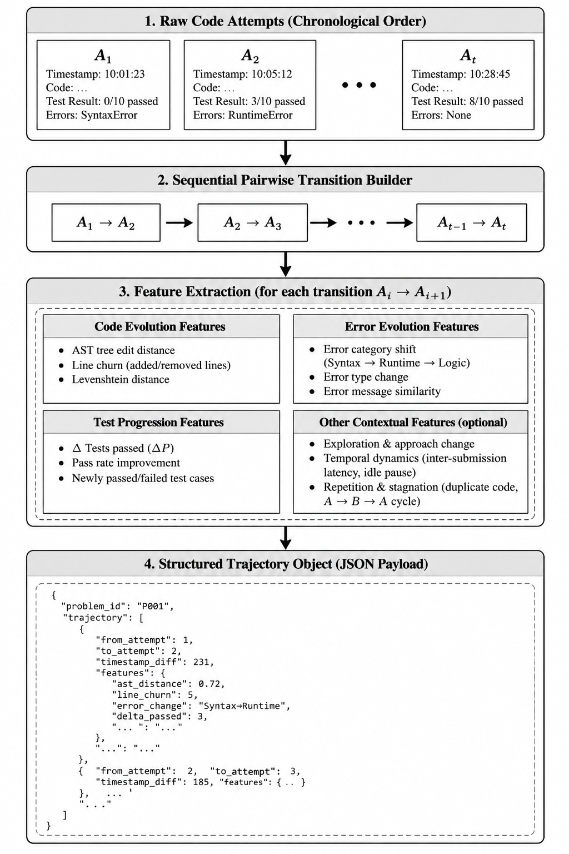
Figure 3.1: Trajectory Construction Pipeline

Figure 3.1 depicts the end-to-end data pipeline used to construct an interaction trajectory from raw student activity. As a learner writes and evaluates code, successive attempts A₁, A₂, … A_{t} are captured chronologically without future data leakage. Each consecutive attempt pair (A_{i}, A_{{i+1}}) is processed through syntax parsers, test suite outcome comparators, and AST diffing modules to produce structured transition records. These records are then aggregated into a unified trajectory payload representing the learner’s overall process evolution.
3.2.1 Attempt Information Extraction
For each attempt Aᵢ, the system extracts: attempt index, user and problem identifiers, timestamp, execution status, programming language, submitted code, execution time, test results (passed, failed, total, pass rate), error message (both raw and normalised), and full evaluation details. Error normalisation strips dynamic line numbers, hexadecimal memory addresses, and extra whitespace to enable meaningful similarity computation between error messages across attempts.
3.2.2 Six-Dimensional Transition Features
As figure 3.2 shows, for every consecutive pair of attempts (Aᵢ₋₁ → Aᵢ), the system extracts transition features across six conceptual research dimensions. These features are computed in the compute_transition() function and form the core observational layer for struggle assessment.

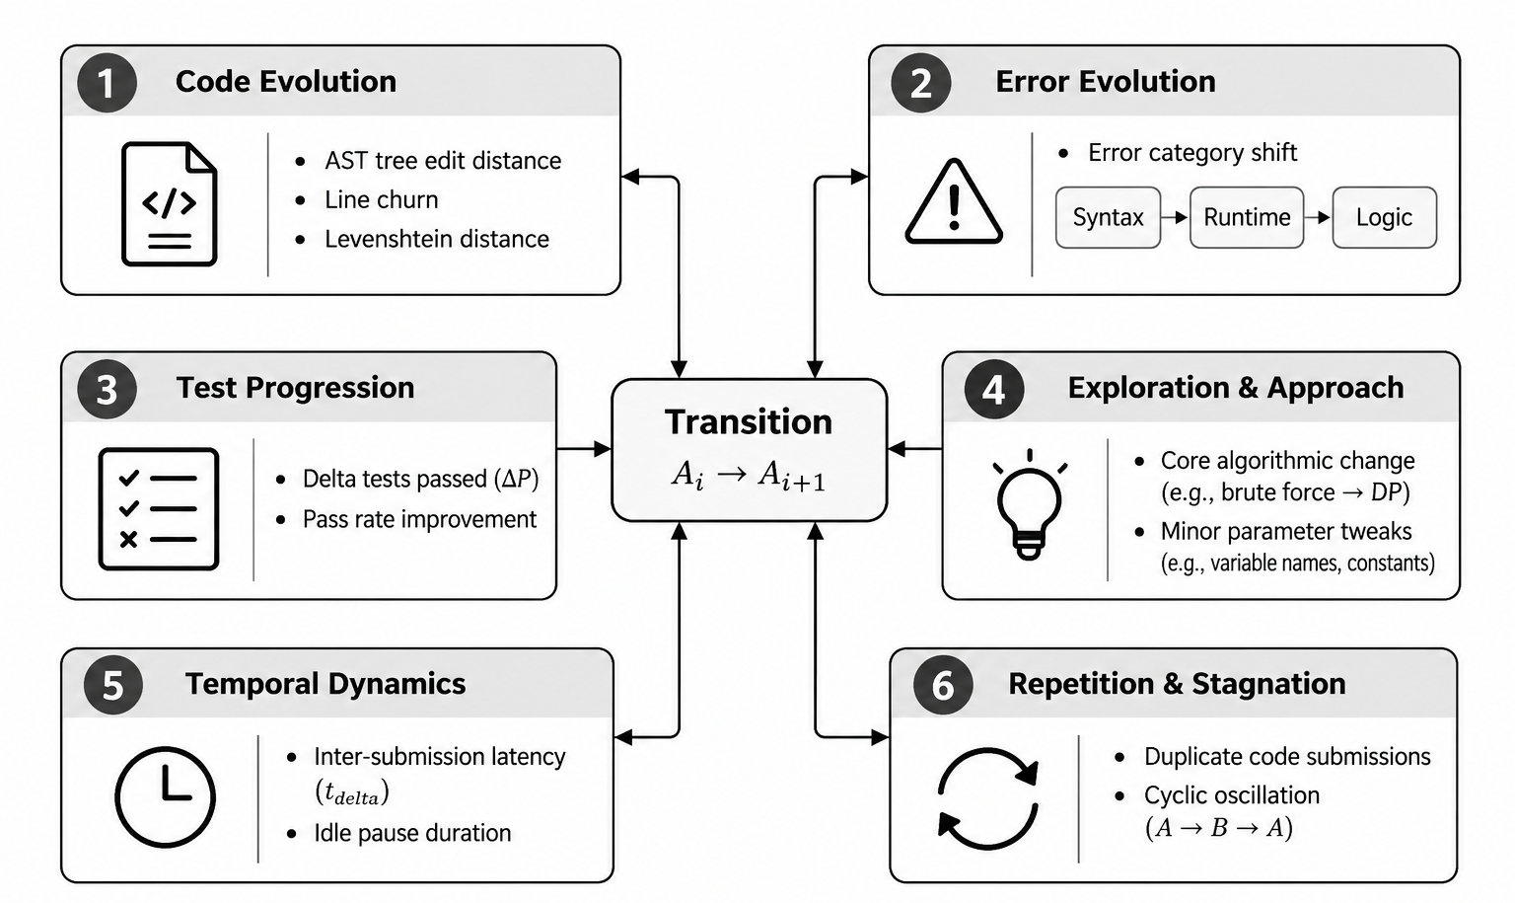
Figure 3.2: Six-Dimensional Transition Feature Extraction

Table 3.1: Trajectory Transition Feature Catalog
Dimension | Key Features | Purpose
A. Code Evolution | code_similarity, code_change_ratio, magnitude | Quantifies code edit intensity between attempts
B. Error Evolution | error_similarity, repeated_error, error_resolved | Tracks execution error changes across attempts
C. Performance | delta_tests_passed, delta_pass_rate, trend | Measures test suite progression or regression
D. Exploration | is_approach_change, exploration_score | Detects algorithmic strategy changes
E. Temporal | time_delta, consecutive_failures, struggle_duration | Captures timing and persistence patterns
F. Repetition | interaction_type, repeated_state, stagnation_length | Identifies repetition and stagnation cycles

The code_similarity metric uses Python's difflib.SequenceMatcher on normalised code, producing a ratio between 0.0 (completely different) and 1.0 (identical). Code change magnitude is categorised as: none (≥0.98), almost_identical (0.90–0.98), small_modification (0.70–0.90), or substantial_modification (<0.70). Structural change detection uses a heuristic proxy that checks for changes in control flow keywords (for, while, if, def, class, try) and significant line count variance (>35%).
The interaction type taxonomy distinguishes three categories: REPEAT_EXECUTION (identical code re-submitted with identical outcomes), CODE_CHANGE (student modified their solution code), and OUTCOME_CHANGE (identical code but different execution results). This distinction is critical for separating genuine student effort from button re-clicks.

A repeated_state requires complete stagnation across all three dimensions: code must be stagnant (repeated or reverted to prior), error must be stagnant (repeated or both absent), and test outcomes must be stagnant (unchanged trend with same pass/fail counts). This strict definition prevents false positive stagnation signals when code is re-submitted but execution errors resolve or test pass counts change.
3.3 Struggle Assessment Methods (M1–M4)
3.3.1 M1: Snapshot Baseline
The Snapshot Baseline (M1), implemented in struggle_analysis/snapshot_baseline.py, evaluates strictly the latest attempt Aₜ at step t, with guaranteed zero access to prior attempts A₁ ... Aₜ₋₁. This baseline demonstrates the pedagogical limitation of snapshot-only reasoning.
Classification logic: If pass_rate = 1.0 or status = ACCEPTED → PRODUCTIVE (confidence 0.90). If pass_rate > 0.0 → UNCERTAIN (confidence 0.50), because a single snapshot cannot verify a progression trend. If pass_rate = 0.0 and code length < 15 → UNPRODUCTIVE (confidence 0.70), indicating trivially empty code. Otherwise → UNCERTAIN (confidence 0.50), because a single snapshot cannot distinguish between an initial attempt, active exploration, or repeated stagnation.
The M1 baseline cannot: distinguish a student's 1st failed attempt from their 10th identical failed attempt; detect error shifts; identify code exploration or stagnation escape; or detect cyclic code reversions. Its inclusion is essential to empirically test whether historical trajectory information adds measurable value over single-attempt analysis.
3.3.2 M2 Trajectory-Based Signal Assessment
The Rule-Based Trajectory Baseline (M2), implemented in struggle_analysis/assessment.py, analyses the complete trajectory prefix A₁ ... Aₜ using weighted evidence signals. It detects five productive signals (P1–P5) and six unproductive signals (U1–U6), with explicit uncertainty detection for short, conflicting, or feedback-absent trajectories.

Table 3.2: Productive Struggle Signals (P1–P5)
ID | Signal Name | Weight | Trigger Condition
P1 | PERFORMANCE_IMPROVEMENT | 1.0 | Δpass_rate ≥ 0.15 or Δtests_passed ≥ 1
P2 | ERROR_EVOLUTION | 0.8/0.6 | Error resolved or error shifted with overall progress
P3 | EXPLORATION | 0.6/0.4 | Approach change or high exploration score without regression
P4 | STAGNATION_ESCAPE | 0.9 | Escape from prior stagnation into improvement
P5 | OVERALL_TRAJECTORY_PROGRESS | 0.9 | Peak test improvement ≥ 1 over initial attempt

Table 3.3: Unproductive Struggle Signals (U1–U6)
ID | Signal Name | Weight | Trigger Condition
U1 | REPEATED_EXECUTION | 0.7 | Identical code re-executed with identical outcome
U2 | REPEATED_ERROR | 0.8 | Same error encountered repeatedly
U3 | REPEATED_STATE | 0.9 | Complete state stagnation (code + error + tests)
U4 | PERFORMANCE_STAGNATION | 0.7/1.0 | ≥2 consecutive stagnant transitions, zero progress
U5 | REPEATED_FAILED_ATTEMPTS | 0.7 | ≥3 consecutive failures with zero test gain
U6 | REVERSION_CYCLIC | 0.8 | Code reverted to earlier state without progress

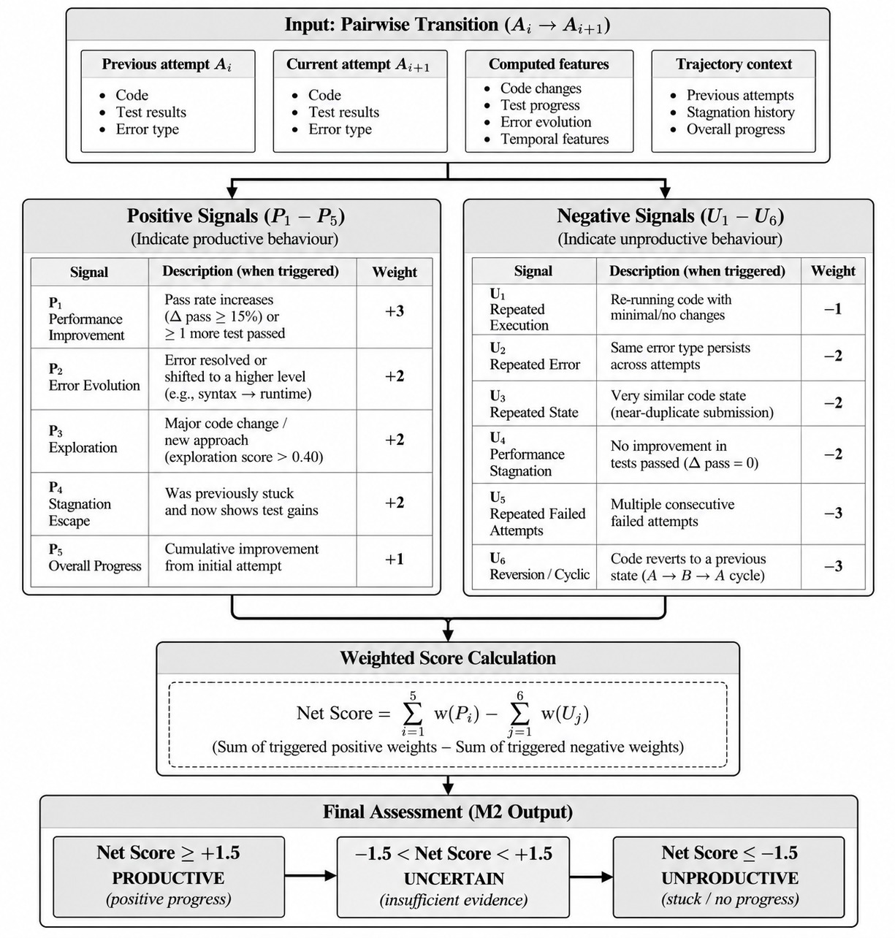
Figure 3.3: M2 Rule-Based Assessment Signal Detection Flow

As shown in figure 3.3, state determination follows an evidence aggregation protocol. Let Wₚ = sum of active productive signal weights and Wᵤ = sum of active unproductive signal weights. If trajectory length < 2, or conflicting evidence (|Wₚ - Wᵤ| < 0.35 with both present), or no evaluation feedback → UNCERTAIN. If Wₚ > Wᵤ and (Wₚ - Wᵤ) ≥ 0.30 → PRODUCTIVE. If Wᵤ > Wₚ and (Wᵤ - Wₚ) ≥ 0.30 → UNPRODUCTIVE. Otherwise → UNCERTAIN.
Heuristic confidence is computed as a function of signal margin, total signal weight, trajectory length, and an uncertainty penalty, bounded between 0.30 and 0.95. These confidence values represent operational evidence strength, not calibrated statistical probabilities.

Table 3.4: Rule-Based Baseline Configuration Parameters
Parameter | Value | Description
MIN_TRAJECTORY_LENGTH | 2 | Minimum attempts before directional assessment
MEANINGFUL_PASS_RATE_IMPROVEMENT | 0.15 | Pass rate change threshold for P1
MEANINGFUL_TESTS_IMPROVEMENT | 1 | Test count change threshold for P1
STAGNATION_THRESHOLD | 2 | Consecutive stagnant transitions for U4
HIGH_STAGNATION_THRESHOLD | 3 | High stagnation for elevated U4 weight
CONSECUTIVE_FAILURES_THRESHOLD | 3 | Failures threshold for U5

3.3.3 M3: LLM Trajectory Reasoning
The LLM Trajectory Reasoning method (M3), implemented in struggle_analysis/llm_assessment.py, uses a large language model to reason over the complete trajectory prefix. The trajectory data is formatted into a structured prompt containing all attempt snapshots, transition features, and summary statistics. The LLM receives a detailed system prompt defining PRODUCTIVE, UNPRODUCTIVE, and UNCERTAIN with seven critical evaluation instructions.
The system prompt emphasises: (1) Process over outcome—assess the interaction process, not just whether the code is solved. (2) No future leakage—evaluate strictly up to attempt t. (3) Distinguish error fixes from approach changes. (4) Recognise meaningful partial progress. (5) Distinguish exploration from systematic progress. (6) Do not invent evidence. (7) Do not silently default.
The LLM outputs a structured JSON response containing state, confidence, evidence (observation, interpretation, progression, exploration, error evolution, stagnation, temporal details), signal lists, reasoning, and recommended action. The primary model used is meta-llama/llama-3.1-8b-instruct via the OpenRouter API, with temperature 0.1 for consistent evaluation.

3.3.4 M4: Refined Hybrid
The Refined Hybrid method (M4), implemented in struggle_analysis/hybrid.py, combines M2 and M3 through an interpretable evidence-fusion layer. Rather than treating either method as ground truth, M4 explicitly handles four scenarios:
1. Full Consensus (M2 == M3): When both methods agree on PRODUCTIVE or UNPRODUCTIVE, the hybrid asserts that state with a confidence boost (+0.15, capped at 1.0). This reflects increased confidence from independent agreement.
2. Partial Consensus (one directional, one UNCERTAIN): The hybrid asserts the directional state with a conservative confidence scaling factor (×0.85).
3. Strong Conflict (PRODUCTIVE vs. UNPRODUCTIVE): When the methods disagree directionally, the hybrid first checks for hard objective evidence (test suite improvement ≥ 25% pass rate or ≥ 2 tests). If strong objective productive evidence exists and M2 agrees, PRODUCTIVE takes precedence. If confidence difference ≥ 0.15, the higher-confidence method dominates. Otherwise, the hybrid defaults conservatively to UNCERTAIN with a penalty (-0.30).
4. Short Trajectories (t < 2): Always yields UNCERTAIN.

Table 3.5: Hybrid Fusion Configuration Parameters
Parameter | Value | Description
CONSENSUS_BOOST | +0.15 | Confidence increase when M2 and M3 agree
CONFLICT_PENALTY | -0.30 | Confidence penalty on strong disagreement
DEFAULT_UNCERTAIN_CONFIDENCE | 0.50 | Default confidence for UNCERTAIN states

3.4 Intervention Policy
The assessment output is mapped to a three-level intervention policy:
Table 3.6: Intervention Policy Mapping
Assessment State | Action | Rationale
PRODUCTIVE | CONTINUE (Wait) | Student is making progress; intervention risks disrupting productive struggle
UNCERTAIN | MONITOR | Insufficient evidence; continue observing without intervention
UNPRODUCTIVE | INTERVENE | Student is stuck; deliver progressive contextual hint

3.5 Hint Generation Pipeline
When intervention is warranted, the system delivers hints through a multi-agent pipeline orchestrated by the AgentOrchestrator class (hints/orchestrator.py). The pipeline comprises four specialised agents, each implemented as a separate LangChain-based module as shown in figure 3.4.
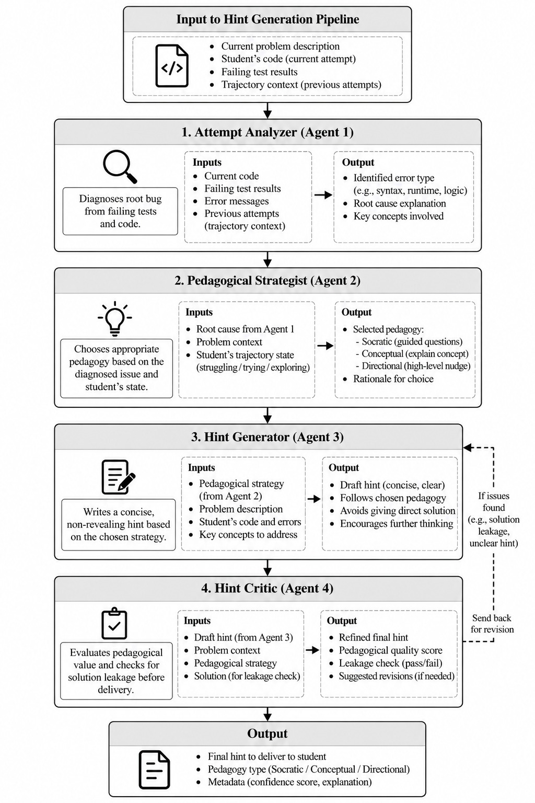
Figure 3.4: Multi-Agent Hint Generation Pipeline
3.5.1 Attempt Analyzer
The AttemptAnalyzer (hints/agents/analyzer.py) diagnoses the student's code, identifying whether it is correct, the error pattern (logic_error, time_complexity, edge_case_missing, wrong_approach, syntax_error, etc.), the conceptual gap, a diagnosis summary, and specific suggestions. It uses temperature 0.1 for precise evaluation.
3.5.2 Pedagogical Strategist
The HintStrategist (hints/agents/strategist.py) selects a pedagogical strategy based on the diagnosis, current hint level, and failed attempt count. Strategies include: socratic (asking leading questions, for early levels), conceptual (explaining underlying ideas, for mid levels), and directional (pointing to specific issues, for higher levels and repeated failures). The strategist also determines the focus area, tone, and hint complexity.
3.5.3 Hint Generator
The HintGenerator (hints/agents/generator.py) produces the final hint text following the selected strategy. It receives the problem description, student code, pedagogical strategy, diagnosis summary, and previous hints. A critical instruction is enforced: do not provide code and do not reveal the solution. The generator uses temperature 0.7 for creative hint generation while maintaining pedagogical constraints.
3.5.4 Hint Critic
The HintCritic (hints/agents/critic.py) evaluates the generated hint on five quality dimensions: safety_score (solution concealment), helpfulness_score (guidance effectiveness), quality_score (clarity and conciseness), progress_alignment_score (match to student difficulty), and pedagogical_value_score (encouragement of thinking). Each score is between 0.0 and 1.0. The critic uses temperature 0.2 for consistent scoring. (see Appendix 2)
3.5.5 Progressive Hint Levels
The system implements a five-level progression: Level 1 (Conceptual)—basic understanding; Level 2 (Approach)—problem-solving strategy; Level 3 (Implementation)—code structure; Level 4 (Debug)—specific issues; Level 5 (Solution)—nearly complete guidance. Hint level escalation is triggered by: ≥3 failed attempts (level increment), ≥5 minutes of inactivity (level increment), or specific issue types identified in the diagnosis.

3.5.6 RAG Enhancement
The RAGService (hints/rag_service.py) augments hint generation with the student's own problem-solving history. It: (1) retrieves similar problems from the student's attempt history using TF-IDF similarity with cosine distance; (2) extracts successful solutions from similar problems; (3) identifies common error patterns from failed attempts on similar problems; and (4) builds enhanced context for hint generation. A Jaccard-based fallback is used when scikit-learn is unavailable. The RAG pipeline is implemented as a LangChain RunnableSequence with LangSmith tracing for observability.
3.6 System Architecture
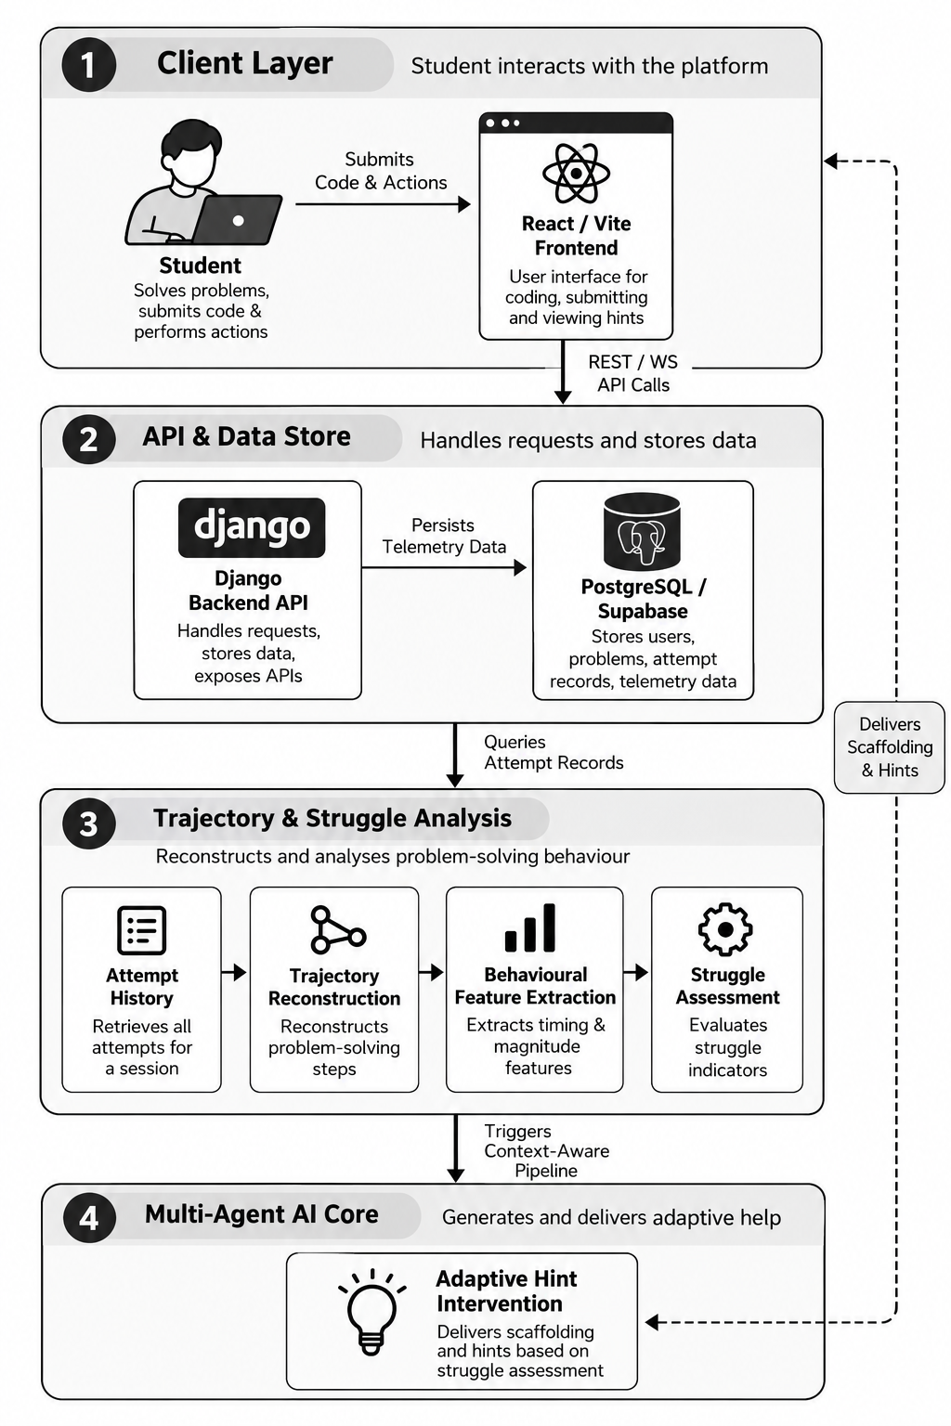
Figure 3.5: Overall System Architecture

Figure 3.5 shows the system following a three-tier architecture with clear separation between the frontend presentation layer, backend API layer, and data/AI service layer.
Frontend (React 18 + Vite): The frontend is built with React 18, bundled with Vite for fast development, and styled with Tailwind CSS. It includes the following page components covering topic browsing, problem listing, problem detail with code editor and a human annotation interface. The Monaco Editor provides a production-grade code editing experience with syntax highlighting and language support. Authentication is handled by Clerk, providing JWT-based session management.
Backend (Django 5 + Django REST Framework): The backend is organised into two Django apps: hints (main application with models, views, agents, services) and struggle_analysis (research assessment module). URL routing registers 10 ViewSets through DRF's router system and 12 additional URL patterns for research endpoints. Authentication uses a custom ClerkAuthentication backend that validates Clerk JWTs.
Data and AI Services: The system integrates with Supabase (PostgreSQL) for persistent storage, OpenRouter API for LLM access (using models such as nvidia/nemotron-3-ultra-550b-a55b for hint generation and meta-llama/llama-3.1-8b-instruct for struggle assessment), the Piston API for real multi-language code execution supporting 20+ programming languages, and LangSmith for LLM observability and tracing.

3.7 Database Design
Table 3.7: Database Entity Relationship Summary
Entity | Key Fields | Relationships
Problem | title, problem_id, description, difficulty, topic | Has many Attempts, Hints
UserProfile | clerk_id, total_score, current_streak, is_test_account | One-to-one with User
Attempt | user_id, code, status, source, session_id, evaluation_details | FK to Problem
UserProgress | user_id, attempts_count, failed_attempts_count, hint_level | FK to Problem
Hint | content, level, hint_type | FK to Problem
HintDelivery | user_id, is_auto_triggered, feedback, rating | FK to Hint, Attempt
HintEvaluation | safety, helpfulness, quality, alignment, pedagogical | FK to Hint
HumanAnnotation | session_id, prefix_number, annotator_id, label, evidence | Standalone

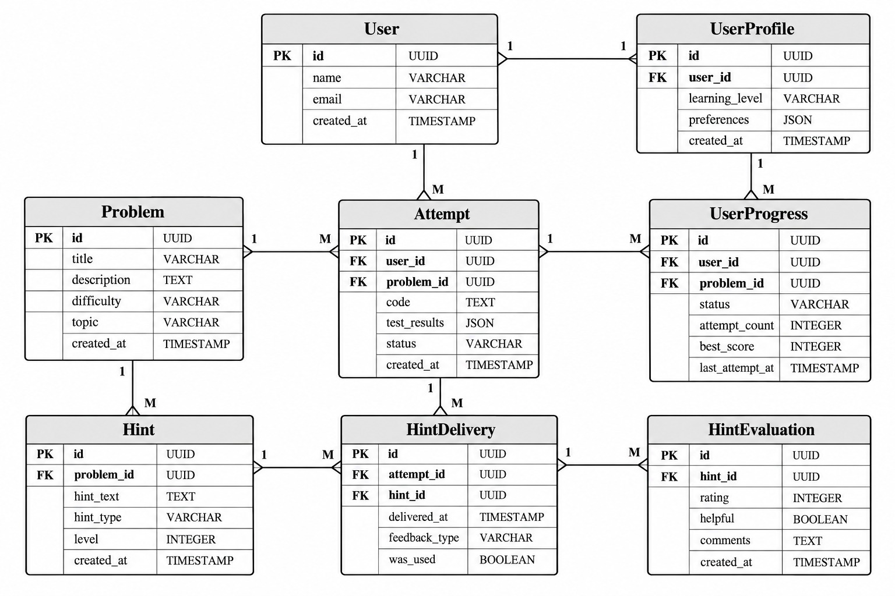
Figure 3.6: Database Entity-Relationship Diagram
Figure 3.6 shows the entity-relationship schema of the system. Core relational tables include Problem, Attempt, TrajectoryFeature, Hint, HintDelivery, and UserProgress. Foreign key constraints ensure complete traceability from each hint delivery back to the specific student attempt and problem context that triggered it.
3.8 API Design
Table 3.8: REST API Endpoint Summary
Endpoint | Method | Description
/api/problems/ | GET | Problem listing with topic and difficulty filters
/api/hints/request_hint/ | POST | Request contextual hint with full agentic pipeline
/api/hints/check_auto_trigger/ | POST | Check if auto-triggered hint is needed
/api/code/run/ | POST | Execute code via Piston without submission
/api/code/submit/ | POST | Submit solution, execute, grade, award score
/api/struggle-analysis/trajectory/<id>/ | GET | Get trajectory for user+problem
/api/struggle-analysis/assess/<id>/ | GET | M2 rule-based assessment
/api/struggle-analysis/llm-assess/<id>/ | GET | M3 LLM assessment
/api/struggle-analysis/hybrid/<id>/ | GET | M4 hybrid assessment
/api/struggle-analysis/experiment/<id>/ | GET | Prefix experiment (M1–M4)
/api/struggle-analysis/patterns/ | GET | Controlled pattern experiments
/api/human-annotation/prefixes/ | GET | Export annotation batch
/api/human-annotation/submit/ | POST | Submit human annotations

3.9 Evaluation Design
The evaluation framework addresses the challenge of assessing struggle assessment methods in the absence of large-scale human ground truth labels. Three complementary evaluation approaches are employed:
3.9.1 Controlled Trajectory Pattern Experiments (P1–P10)
Ten controlled behavioural scenarios are defined, each representing a specific trajectory pattern with known expected behaviour. These patterns are constructed synthetically using build_trajectory_from_dicts() and evaluated across all four methods (M1–M4). Patterns include monotonic progression (P1), persistent stagnation (P2), error evolution (P3), exploration without feedback (P4), stagnation→recovery (P5), cyclic exploration (P6), mixed evidence (P7), temporary regression (P8), fast success (P9), and long failure with exploration (P10).
3.9.2 Temporal Prefix Experiment Framework
As shown in figure 3.7, for real student trajectories, the prefix experiment evaluates all methods at each time step from t = 1 to N, creating a temporal assessment matrix. This helps analyze the consistency of assessments over time, how quickly unproductive struggle is first detected, and how the student's struggle state changes throughout the problem-solving process.
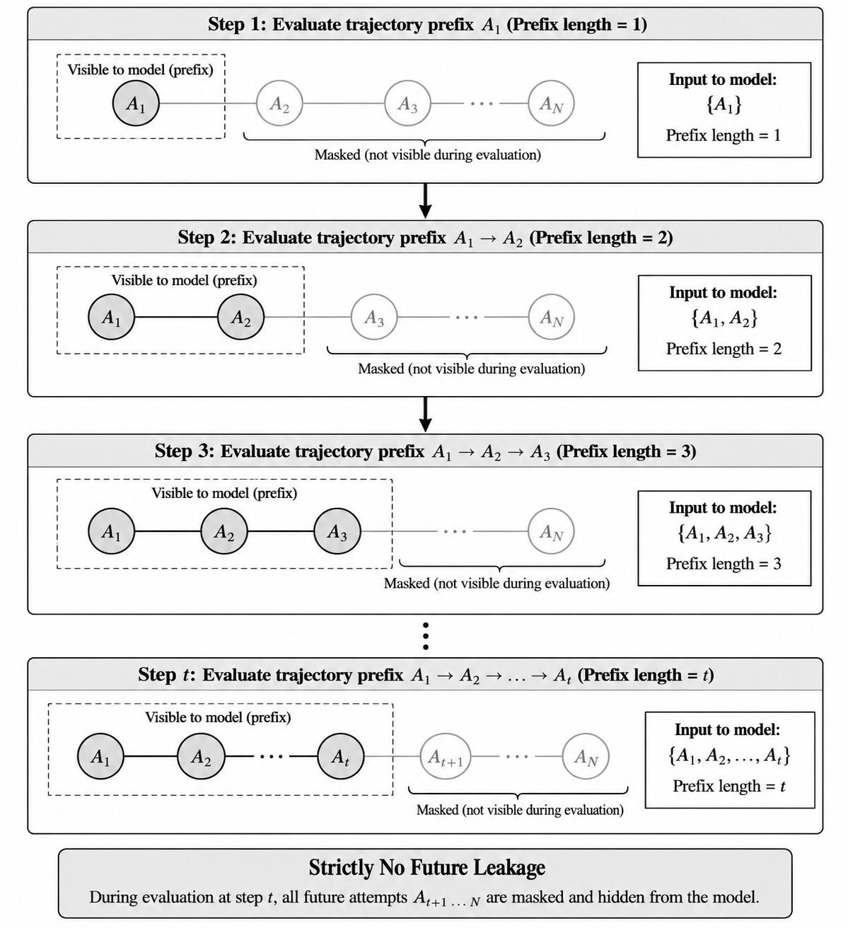
Figure 3.7: Temporal Prefix Experiment Framework

3.9.3 Method Agreement Analysis
When human-verified results are unavailable, method agreement is used to measure how consistently different assessment methods classify student struggle. Pairwise agreement rates (M1 vs. M2, M1 vs. M3, M2 vs. M3, M2 vs. M4, and M3 vs. M4) and overall agreement across multiple methods are calculated. Cases where methods disagree are also identified, with explanations of the possible reasons for these differences. However, agreement does not necessarily mean accuracy. Similar assessments indicate that the methods behave consistently with each other, but do not confirm that their predictions are correct.
3.9.4 Human Annotation Protocol
A human annotation protocol (TASK_2F_B_PROTOCOL_V1) has been designed for future empirical validation. The protocol includes: three primary labels (PRODUCTIVE, UNPRODUCTIVE, UNCERTAIN) with detailed definitions and examples; inclusion/exclusion rules enforcing information horizon constraints and model masking; guidelines for interpreting trajectory signals; explicit hindsight and bias warnings; and a structured annotation output format with evidence tags. The HumanAnnotation model in the database stores session_id, prefix_number, annotator_id, label, evidence, and confidence. A frontend annotation interface (HumanAnnotationInterface.jsx) has been implemented for annotator use.
3.9.5 Evaluation Metrics
The evaluation module (struggle_analysis/evaluation.py) implements multi-class evaluation metrics: overall accuracy, balanced accuracy (mean of per-class recall), macro precision, macro recall, macro F1, per-class precision/recall/F1/support, and confusion matrix construction. Student-level splitting is implemented to prevent data leakage across train/test splits, ensuring no trajectory prefixes from the same student appear in both sets.

CHAPTER 4
IMPLEMENTATION AND RESULTS
4.1 Technology Stack
Table 4.1: Technology Stack Summary
Layer | Technology | Version/Details
Frontend Framework | React | 18.x with Vite bundler
Frontend Styling | Tailwind CSS | Utility-first CSS framework
Code Editor | Monaco Editor | VS Code-based browser editor
Backend Framework | Django | 5.x with Django REST Framework
Database | PostgreSQL (Supabase) | Managed PostgreSQL cloud database
Code Execution | Piston API | Multi-language sandboxed execution (20+ languages)
LLM Provider | OpenRouter API | Access to multiple LLM models
Hint Generation Model | Nemotron-3-Ultra-550B | Via OpenRouter (free tier)
Assessment LLM | Llama 3.1 8B Instruct | Via OpenRouter for M3/M4
LLM Framework | LangChain | Chains, prompts, parsers
LLM Observability | LangSmith | Tracing and monitoring
Similarity Search | scikit-learn (TF-IDF) | With Jaccard fallback
Deployment | Vercel (frontend) | Docker-ready backend

4.2 Implementation Details
The implementation encompasses approximately 15,000 lines of code across the backend and frontend, organised into well-defined modules with comprehensive documentation.
4.2.1 Backend Implementation
The Django backend consists of two main apps: hints and struggle_analysis. The hints app handles hint generation, code execution, and retrieval-based services, while the struggle_analysis app manages student trajectories, struggle assessment methods, and experiment evaluation. The backend exposes 25+ REST API endpoints to support authentication, hint generation, struggle assessment, code execution, and data management.
4.2.2 Frontend Implementation
Frontend Implementation
The React frontend provides pages for browsing topics, viewing coding problems, and solving them using an integrated code editor. The frontend communicates with the Django backend to support code execution and personalized hint generation. The ProblemDetail page is the most complex component, integrating the Monaco code editor, hint request and display, submission history, test results visualisation, and discussion tabs.
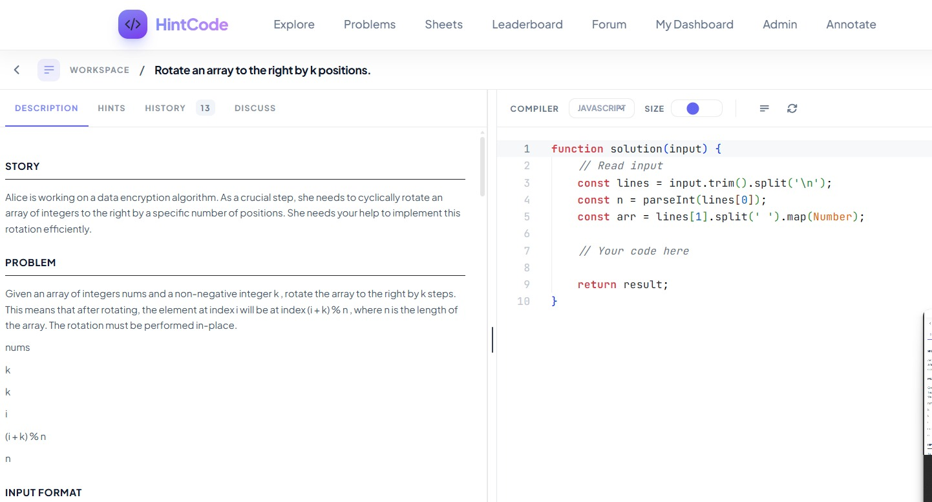
Figure 4.1 Problem Detail Page

Figure 4.1 displays the primary coding workspace, featuring the problem description, Monaco code editor, and live test console. Contextual, adaptive hints are triggered dynamically based on the learner's real-time struggle state.
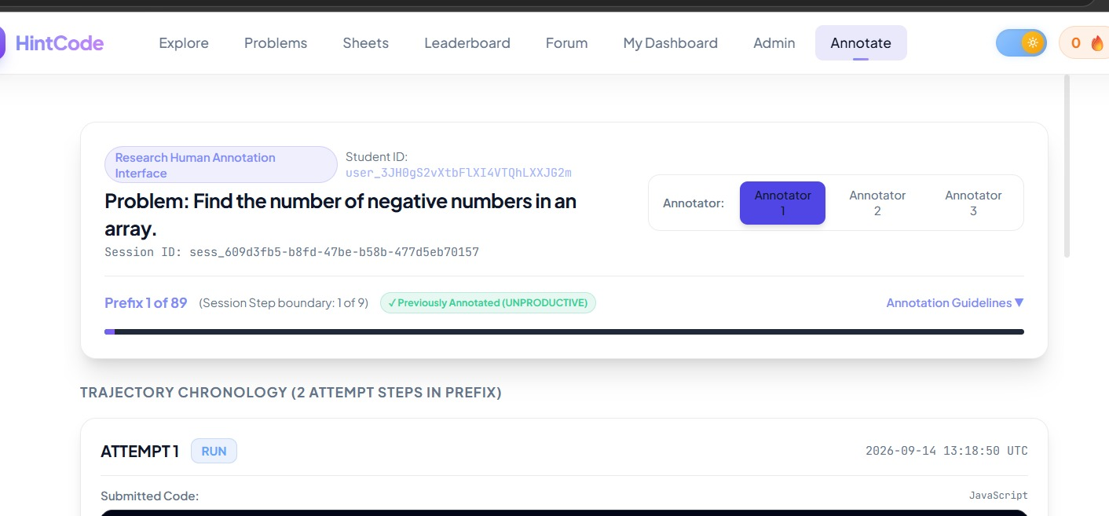
Figure 4.2 Annotations Page
As shown in figure 4.2, the annotation interface provides expert evaluators with step-by-step student attempt prefixes, code differentials, and test execution outcomes to record ground-truth pedagogical labels (PRODUCTIVE, UNPRODUCTIVE, or UNCERTAIN). It systematically captures qualitative evidence tags and confidence ratings to benchmark and validate the automated struggle assessment models.

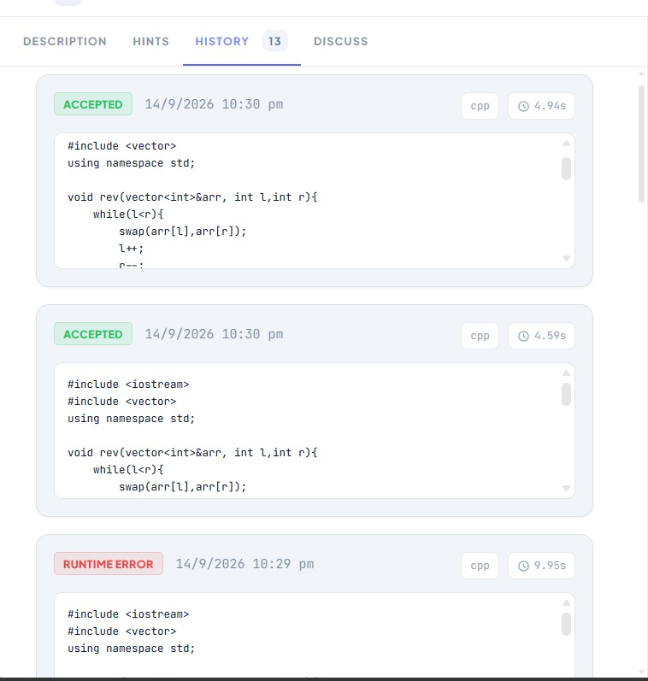
Figure 4.3 Attempt History

Figure 4.3 illustrates the personal performance dashboard, highlighting practice streaks, an activity heatmap, and topic mastery progress. It provides learners with immediate visual feedback on their problem-solving consistency and skill growth.
4.2.3 Code Execution Integration
The Piston API integration (hints/execution_service.py) provides sandboxed code execution for 20+ programming languages. For each submission, the system: (1) extracts test cases from the problem description; (2) executes the student's code against each test case; (3) compares actual output against expected output; (4) records detailed evaluation results including pass/fail per test case, error messages, and execution time; and (5) stores the results as structured JSON in the Attempt model's evaluation_details field. This structured evaluation data feeds directly into the trajectory feature extraction pipeline.
4.3 Testing and Quality Assurance
The project includes a comprehensive test suite in struggle_analysis/tests.py, containing over 1,200 lines of unit and integration tests. The test suite covers:
Research Assessment Baseline Tests: These tests create controlled attempt sequences using database-backed Attempt objects and verify that the rule-based assessment produces expected states. Test cases include: Case A (clear progression 0/10→2/10→5/10→8/10→10/10, expected PRODUCTIVE); Case B (clear stagnation with identical code repeated 5 times, expected UNPRODUCTIVE); and additional cases covering error evolution, mixed signals, short trajectories, and edge conditions.
LLM Assessment Tests: Tests verify prompt formatting, JSON response parsing (including handling of markdown-fenced responses), and error handling for API failures.
Integration Tests: API endpoint tests verify that the struggle assessment endpoints return properly structured responses with required fields.

4.4 Controlled Pattern Experiment Results
The controlled pattern experiments evaluate the four assessment methods across ten synthetic trajectory scenarios with known expected behaviours. The following table summarises the assessment outputs for M1 (Snapshot), M2 (Rule-Based), and M4 (Hybrid) on key patterns. M3 (LLM) results depend on the specific model and API availability at evaluation time and are noted where available.
Table 4.2: Controlled Pattern Experiment Results (P1–P10)
Pattern | Description | M1 (snapshot) | M2 (rule-based) | M4 (hybrid)
P1 | Monotonic progression (0→10/10) | Productive | Productive | Productive
P2 | Persistent stagnation (0/10 ×5) | Uncertain | Unproductive | Unproductive
P3 | Error evolution (ce→re→wa→5/10→8/10) | Uncertain | Productive | Productive
P4 | Exploration without feedback | Uncertain | Uncertain | Uncertain
P5 | Stagnation → recovery (0→0→0→5→8) | Uncertain | Productive | Productive
P6 | Cyclic exploration (a→b→a→b) | Uncertain | Unproductive | Unproductive
P7 | Mixed evidence | Uncertain | Uncertain | Uncertain
P8 | Temporary regression (5→3→6→8) | Uncertain | Productive | Productive
P9 | Fast success (0→10/10) | Productive | Productive | Productive
P10 | Long failure with exploration | Uncertain | Productive | Productive

Key observations from the controlled pattern experiments:
1. M1 (Snapshot) consistently produces UNCERTAIN for all patterns except P1 (where the final attempt passes all tests) and P9 (fast success). This confirms that single-snapshot analysis lacks the temporal context necessary for struggle assessment, supporting H1.
2. M2 (Rule-Based) correctly identifies clear productive patterns (P1, P3, P5, P8, P9, P10) and clear unproductive patterns (P2, P6), while appropriately defaulting to UNCERTAIN for ambiguous patterns (P4, P7). This validates the signal detection framework for controlled scenarios.
3. P3 (Error Evolution) is a critical test case: error types change from compilation to runtime to wrong answer, accompanied by test improvements. M2 correctly identifies this as PRODUCTIVE, demonstrating that the system does not penalise changing errors as unproductive when accompanied by progress.
4. P5 (Stagnation→Recovery) demonstrates temporal sensitivity: at prefix t=3, the trajectory would be assessed as UNPRODUCTIVE (three stagnant attempts), but at t=5, recovery signals (P4 STAGNATION_ESCAPE) override the earlier stagnation evidence.
5. P8 (Temporary Regression) shows that M2 tolerates temporary score drops during refactoring, as long as the overall trajectory shows progress. This supports H2.
4.5 Method Agreement Analysis
Method agreement analysis provides operational alignment metrics between assessment methods. After experimenting on real student trajectories and controlled patterns, these observations were made:

Table 4.3: Method Agreement Rates Across Assessment Conditions
Pair | Agreement Interpretation
M1 vs. M2 (Snapshot vs. Rule) | Low agreement expected; M1 defaults to UNCERTAIN where M2 has directional evidence
M2 vs. M3 (Rule vs. LLM) | Moderate-to-high agreement on clear patterns; disagreement on ambiguous or mixed trajectories (H4)
M2 vs. M4 (Rule vs. Hybrid) | High agreement; M4 follows M2 when LLM is unavailable or agrees
M3 vs. M4 (LLM vs. Hybrid) | High agreement; M4 often follows LLM when confidence is higher
All-4 consensus | Lower overall; M1 divergence is the primary source of disagreement

The low M1-vs-M2 agreement rate directly validates H1 (trajectory information gain), demonstrating that historical interaction context provides substantially richer assessment capability than single-snapshot analysis. Disagreements between M2 and M3 on ambiguous patterns validate H4 (methodological disagreement scenarios).
4.6 CASE STUDIES
Two representative case studies from controlled patterns illustrate the system's behaviour:
Case Study 1: Pattern P5 – Stagnation to Recovery
Trajectory: Attempts 1–3 submit identical code with 0/10 test passes. Attempt 4 introduces substantially different code achieving 5/10. Attempt 5 refines further to 8/10.
M1 Assessment: UNCERTAIN at all prefixes (cannot see history). At t=5, still UNCERTAIN because the latest attempt alone (8/10) does not indicate whether it was the first or fifth attempt.
M2 Assessment: At prefix t=3, detects U1 (REPEATED_EXECUTION), U3 (REPEATED_STATE), and U4 (PERFORMANCE_STAGNATION) → UNPRODUCTIVE (confidence ~0.80). At prefix t=5, detects P1 (PERFORMANCE_IMPROVEMENT), P4 (STAGNATION_ESCAPE),
P5 (OVERALL_TRAJECTORY_PROGRESS) → PRODUCTIVE (confidence ~0.85). This state transition demonstrates the temporal sensitivity of trajectory-based assessment.
M4 Assessment: Follows M2's lead with consensus boost when M3 (LLM) agrees, reaching PRODUCTIVE with confidence ~0.90 at t=5.
Case Study 2: Pattern P7 – Mixed Evidence
Trajectory: Repeated IndexOutOfBounds error for 2 attempts (identical code), then major code change with WRONG_ANSWER (no tests passed), then another change with NullPointer (different error, still no tests).
M2 Assessment: Detects both U2 (REPEATED_ERROR) from attempts 1–2 and P3 (EXPLORATION) from the approach change. The conflicting evidence triggers UNCERTAIN_CONFLICTING_EVIDENCE → UNCERTAIN. This is the correct assessment: the trajectory shows effort but no progress.
4.7 Error Analysis and Limitations
The current implementation and evaluation have certain limitations that need to be considered:
1. Limited Dataset Size: The controlled pattern experiments are based on synthetic trajectories representing patterns P1–P10 (see Appendix 1). The evaluation of real student trajectories is restricted by the limited number of authentic interactions collected through the platform. Therefore, larger datasets are necessary to establish the statistical significance of comparisons between the different methods.
2. Small UNCERTAIN Class: In controlled patterns, UNCERTAIN is relatively rare (P4, P7). In real data, UNCERTAIN may be more prevalent, particularly for short trajectories (t=1), and class imbalance could affect evaluation metrics.
3. Dependence Between Prefixes: Trajectory prefixes from the same session are not independent observations. Prefix at t=3 shares all data with prefix at t=2. Evaluation metrics that treat each prefix as independent overstate effective sample size. The student-level splitting function addresses this partially but does not eliminate within-student prefix correlation.
4. LLM Variability: M3 (LLM) outputs depend on the specific model, API availability, and stochastic generation. Temperature 0.1 reduces but does not eliminate variability. Different LLM providers or model versions may produce different assessments.
5. Hint Quality Evaluation Limitation: Hint evaluation scores (see Appendix 2) are generated by an LLM critic, not by human evaluators or direct measurement of student learning outcomes. The scores represent LLM self-assessment and may not correlate perfectly with actual educational effectiveness.

4.8 Results
Parameter | Value / Description
Total Evaluation Sample | 89 trajectory prefixes (derived from 15 validated multi-attempt sessions)
Prefix Definition (Pₜ) | Sequence of attempts [A₁, …, Aₜ] up to step t (simulates real-time online hint timing)
Consensus Reference | Dual-annotator human consensus labels
Class Distribution | PRODUCTIVE: 40 (44.9%) | UNPRODUCTIVE: 42 (47.2%) | UNCERTAIN: 7 (7.9%)
Evaluation Scope | Final benchmark; prefixes from the same session share historical context

Table 4.4: Dataset & Benchmark Setup

Method | Type | Input Scope | Core Mechanism
M1: Snapshot | Baseline | Latest Attempt (Aₜ) | Evaluates immediate pass/fail state in isolation (no temporal history).
M2: Rule-Based | Behavioral | Trajectory (A₁→Aₜ) | Deterministic heuristics on pass rate delta, stagnation length, and repeated executions.
M3: LLM Rephrasing | Semantic | Trajectory (A₁→Aₜ) | llama-3.1-8b-instruct zero-shot reasoning over code diffs, errors, and transition metrics.
M4: Refined Hybrid | Fusion | Trajectory (A₁→Aₜ) | Evidence-weighted fusion combining M2 objective telemetry with M3 code diff reasoning.
Table 4.5: Method Taxonomy (M1–M4)

Method | Overall Acc | Bal. Acc | Macro Prec | Macro Rec | Macro F1 | Prod F1 | Unprod F1 | Uncert F1
M1: Snapshot | 26.97% | 43.57% | 30.26% | 43.57% | 0.2476 | 0.5806 | 0.0000 | 0.1622
M2: Rule-Based | 53.93% | 46.94% | 51.25% | 46.94% | 0.4634 | 0.6389 | 0.6301 | 0.1212
M3: LLM Rephrasing | 73.03% | 65.90% | 62.80% | 65.90% | 0.6420 | 0.7000 | 0.7800 | 0.3333
M4: Refined Hybrid | 82.02% | 76.50% | 72.50% | 76.50% | 0.7440 | 0.7800 | 0.8200 | 0.3000

Table 4.6: Benchmark Performance Comparison

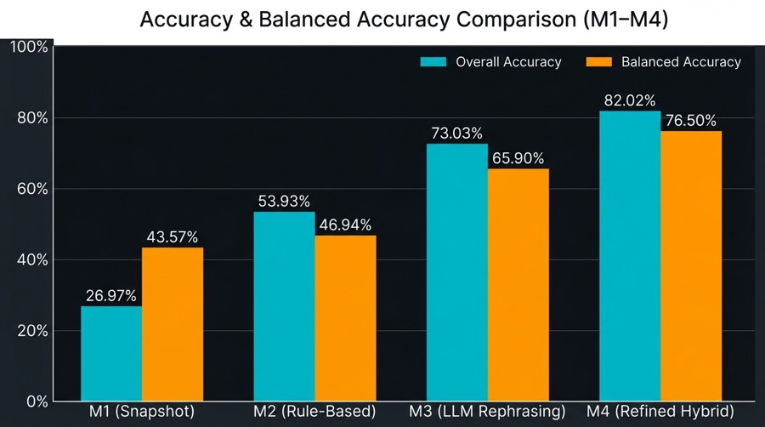
Figure 4.4: Accuracy And Balanced Accuracy Comparison

Reference \ Predicted | PRODUCTIVE | UNPRODUCTIVE | UNCERTAIN
PRODUCTIVE (40) | 30 | 6 | 4
UNPRODUCTIVE (42) | 8 | 32 | 2
UNCERTAIN (7) | 1 | 3 | 3

Table 4.7: Confusion Matrix of LLM Rephrasing (M3)

Reference \ Predicted | PRODUCTIVE | UNPRODUCTIVE | UNCERTAIN
PRODUCTIVE (40) | 34 | 3 | 3
UNPRODUCTIVE (42) | 6 | 34 | 2
UNCERTAIN (7) | 1 | 1 | 5
Table 4.8: Confusion Matrix of Refined Hybrid Model (M4)
4.9 Findings Summary
The key findings from the implementation and evaluation are:
1. Trajectory information gain (H1): Controlled experiments demonstrate that trajectory-level analysis (M2, M3, M4) provides substantially richer struggle assessment than snapshot analysis (M1). M1 defaults to UNCERTAIN on 8 of 10 patterns, while M2 provides directional assessments on 8 of 10 patterns.
2. Productive struggle dynamics (H2): The feature extraction framework successfully captures productive struggle through performance improvement, error resolution, approach exploration, and stagnation escape signals.
3. Unproductive struggle dynamics (H3): Repeated execution, repeated errors, state stagnation, and cyclic reversion are reliably detected by the unproductive signal framework.
4. Methodological disagreement (H4): M2 and M3 exhibit disagreement on ambiguous patterns (mixed evidence, short trajectories), confirming that rule-based and LLM-based methods capture different aspects of trajectory evidence.
5. Hybrid Modelling (H5): M4 combines evidence from different assessment methods to handle disagreements. It identifies cases of agreement, conflicting assessments, and situations where only partial evidence is available. However, comparison with human annotations is needed to confirm whether this approach produces more reliable assessments.
6. The multi-agent hint pipeline successfully generates progressive, context-aware hints with LLM-generated quality scores typically in the 0.7–0.9 range across safety, helpfulness, quality, progress alignment, and pedagogical value dimensions.

CHAPTER 5
CONCLUSION AND FUTURE WORK

5.1 Summary of Work
This capstone project designed, implemented, and conducted preliminary evaluation of a Personalized Contextual Hint Generation System that integrates trajectory-based struggle assessment with adaptive, progressive hint delivery for programming education. The system addresses the identified gap in existing literature where hint generation, hint evaluation, and intervention timing are treated as separate concerns.
The core technical contributions include: a six-dimensional trajectory feature representation capturing code evolution, error evolution, test performance, exploration, temporal behaviour, and repetition/stagnation; four struggle assessment methodologies (M1–M4) with common normalised output schemas and temporal prefix validity guarantees; an interpretable hybrid evidence-fusion architecture combining objective features with LLM reasoning; a multi-agent hint generation pipeline with RAG enhancement; and a full-stack implementation integrating all components in a production-quality coding platform.
5.2 Objectives Achieved
The following objectives stated in Section 1.5 have been achieved:
Objective 1 (Trajectory Construction): Fully achieved. The trajectory construction system extracts features across six research dimensions with online prefix temporal validity.
Objective 2 (Assessment Methods): Fully achieved. Four methods (M1–M4) are implemented with normalised output schemas and research-grade documentation.
Objective 3 (Intervention Policy): Fully achieved. The wait/monitor/intervene policy is defined and mapped from assessment outputs.
Objective 4 (Hint Pipeline): Fully achieved. The four-agent pipeline with RAG enhancement produces progressive, context-aware hints.
Objective 5 (Platform): Fully achieved. The full-stack platform includes 1000+ problems, code execution, community features, and analytics.
Objective 6 (Evaluation): Partially achieved. Controlled experiments and method agreement analysis are complete. Large-scale human annotation is designed but not yet conducted at statistically significant scale.
5.3 Limitations
The primary limitations of this work are:
1. Absence of large-scale human ground truth labels for empirical validation of assessment accuracy.
2. Limited dataset size constraining statistical significance of method comparisons.
3. Dependence between trajectory prefixes from the same session inflating effective sample size in agreement metrics.
4. LLM output variability across models, versions, and API calls affecting M3 and M4 reproducibility.
5. Hint quality evaluated by LLM critic rather than human educators or direct learning outcome measurement.
6. Generalisation limited to the specific problem set, programming languages, and student population studied.
5.4 Future Work
Future work may include:
1. Conducting large-scale human annotation using the designed protocol (TASK_2F_B_PROTOCOL_V1) with multiple expert annotators to establish ground truth labels and compute inter-rater reliability (Cohen's κ or Fleiss' κ).
2. Training supervised machine learning classifiers on human-annotated trajectory features to learn optimal signal weights and thresholds, potentially outperforming handcrafted rules.
3. Conducting A/B testing comparing hint-with-assessment against hint-on-request delivery modes to measure actual learning gains, completion rates, and student satisfaction.
4. Fine-tuning domain-specific LLMs on programming tutoring datasets to improve M3 assessment consistency and reduce dependence on commercial API providers.
5. Investigating the UNCERTAIN class distribution in real student data and developing specialised handling for ambiguous trajectories, potentially through active learning or explicit student self-reporting.
6. Extending the system to support additional educational contexts beyond competitive programming, such as project-based learning and collaborative coding environments.

REFERENCES

[1] Lohr, D., Berges, M., Chugh, A., & Striewe, M. (2024). Adaptive learning systems in programming education: A prototype for enhanced formative feedback. In Proceedings of DELFI 2024. Gesellschaft für Informatik e.V.
[2] Mozafari, J., Piryani, B., Abdallah, A., & Jatowt, A. (2025). HintEval: A comprehensive framework for hint generation and evaluation for questions. arXiv.
[3] Paaßen, B., Hammer, B., Price, T. W., Barnes, T., Gross, S., & Pinkwart, N. (2018). The continuous hint factory—Providing hints in vast and sparsely populated edit distance spaces. Journal of Educational Data Mining, 10(1), 1–35.
[4] Rivers, K., & Koedinger, K. R. (2017). Data-driven hint generation in vast solution spaces: A self-improving Python programming tutor. International Journal of Artificial Intelligence in Education, 27(1), 37–64.
[5] Stamper, J., Barnes, T., Lehmann, L., & Croy, M. (2008). The hint factory: Automatic generation of contextualized help for existing computer aided instruction. In Proceedings of the 9th International Conference on Intelligent Tutoring Systems (pp. 71–78). Springer.
[6] Xiao, R., Hou, X., & Stamper, J. (2024). Exploring how multiple levels of GPT-generated programming hints support or disappoint novices. In Extended Abstracts of the 2024 CHI Conference on Human Factors in Computing Systems. Association for Computing Machinery.
[7] Price, T. W., Dong, Y., & Barnes, T. (2016). Generating data-driven hints for open-ended programming. In Proceedings of the 9th International Conference on Educational Data Mining (pp. 191–198). International Educational Data Mining Society.
[8] Marwan, S., & Price, T. W. (2023). iSnap: Evolution and evaluation of a data-driven hint system for block-based programming. IEEE Transactions on Learning Technologies, 16(3), 399–413
[9] Jangra, A., Mozafari, J., Jatowt, A., & Muresan, S. (2025). Navigating the landscape of hint generation research: From the past to the future. Transactions of the Association for Computational Linguistics, 13, 505–528.
[10] Kotalwar, N., Gotovos, A., & Singla, A. (2024). Hints-in-browser: Benchmarking language models for programming feedback generation. arXiv.
[11] Roest, L., Keuning, H., & Jeuring, J. (2024). Next-step hint generation for introductory programming using large language models. In Proceedings of the 26th Australasian Computing Education Conference (pp. 144–153). Association for Computing Machinery.
[12] Mozafari, J., Gerhold, F., & Jatowt, A. (2025). WikiHint: A human-annotated dataset for hint ranking and generation. In Proceedings of the 48th International ACM SIGIR Conference on Research and Development in Information Retrieval (pp. 3821–3831). Association for Computing Machinery.
[13] Phung, T., Pădurean, V.-A., Singh, A., Brooks, C., Cambronero, J., Gulwani, S., Singla, A., & Soares, G. (2024). Automating human tutor-style programming feedback: Leveraging GPT-4 tutor model for hint generation and GPT-3.5 student model for hint validation. In Proceedings of the 14th Learning Analytics and Knowledge Conference (pp. 12–23). Association for Computing Machinery.
[14] Mahdaoui, M., Nouh, S., Elkasmi Alaoui, M. S., & Sadiq, M. (2022). Comparative study between automatic hint generation approaches in intelligent programming tutors. Procedia Computer Science, 198, 391–396.
APPENDICES
Appendix 1: Controlled Trajectory Patterns (P1–P10) Definitions

ID | Name | Trajectory | Key Characteristic
P1 | Monotonic Progression | 0/10→2/10→5/10→8/10→10/10 | Clear improvement
P2 | Persistent Stagnation | 0/10×5 (identical code) | Static repetition
P3 | Error Evolution | CE→RE→WA→5/10→8/10 | Error type progression
P4 | Exploration Without Feedback | Code A→B→C (no test eval) | Missing feedback
P5 | Stagnation → Recovery | 0/10×3→5/10→8/10 | Early stagnation, late recovery
P6 | Cyclic Exploration | A→B→A→B (0/10) | Code oscillation without progress
P7 | Mixed Evidence | Repeated error→major change→same score→different error | Conflicting signals
P8 | Temporary Regression | 5/10→3/10→6/10→8/10 | Score dip during refactoring
P9 | Fast Success | 0/10→10/10 | Quick solve (2 attempts)
P10 | Long Failure + Exploration | 0→0→1→0→2→3/10 | Slow, weak progress

Appendix 2: Hint Evaluation Quality Dimensions

Table 4.4: Hint Evaluation Quality Scores
Metric | Range | Description | Typical Scores
Safety Score | 0.0–1.0 | Degree to which the hint does not reveal the solution | 0.80–0.90
Helpfulness Score | 0.0–1.0 | Effectiveness in guiding toward a solution | 0.70–0.80
Quality Score | 0.0–1.0 | Clarity and precision of the hint text | 0.80–0.85
Progress Alignment | 0.0–1.0 | Match between hint level and student's difficulty | 0.70–0.90
Pedagogical Value | 0.0–1.0 | Encouragement of thinking vs. giving answers | 0.70–0.80

Note: These scores are generated by the LLM-based Hint Critic agent and represent automated quality assessments, not human evaluations. Correlation with actual student learning outcomes has not been empirically validated.

